R PROGRAMMING

EXPERIMENT-1

ADDITION:

AIM:

To prove the program for addition using R-tool.

PROGRAM:

num1=as.integer(readline(prompt = "enter the first number:"))

num2=as.integer(readline(prompt = "enter the second number:"))

num3=num1+num2

print(num3)

OUTPUT:

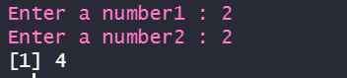

RESULT:

Thus the basic program addition are executed successfully.

EXPERIMENT-2

SUBTRACTION:

AIM:

To prove the program for subtraction using R-tool.

PROGRAM:

num1=as.integer(readline(prompt = "enter the first number:"))

num2=as.integer(readline(prompt = "enter the second number:"))

num3=num1-num2

print(num3)

OUTPUT:

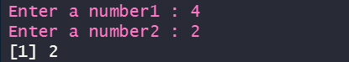

RESULT:

Thus the basic program subtraction are executed successfully.

EXPERIMENT-3

MULTIPLICATION:

AIM:

To prove the program for multiplication using R-tool.

PROGRAM:

num1=as.integer(readline(prompt = "enter the first number:"))

num2=as.integer(readline(prompt = "enter the second number:"))

num3=num1*num2

print(num3)

OUTPUT:

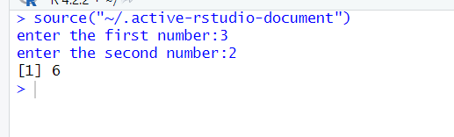

RESULT:

Thus the basic program multiplication are executed successfully.

EXPERIMENT-4

DIVISION:

AIM:

To prove the program for division using R-tool.

PROGRAM:

num1=as.integer(readline(prompt = "enter the first number:"))

num2=as.integer(readline(prompt = "enter the second number:"))

num3=num1/num2

print(num3)

OUTPUT:

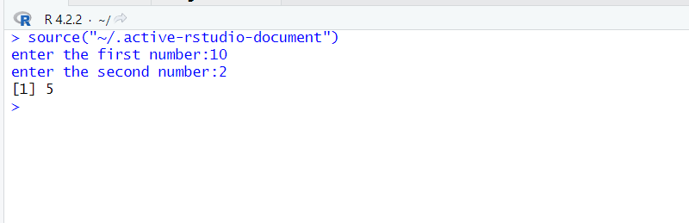

RESULT:

Thus the basic program division was executed successfully.

EXPERIMENT-5

ODD OR EVEN:

AIM:

To write the program for odd or even using R-tool.

PROGRAM:

num=as.integer(readline(prompt="enter a number:"))

if((num%%2)==0)

{

print("number is a even")

}else{

print("number is odd")

}

OUTPUT:

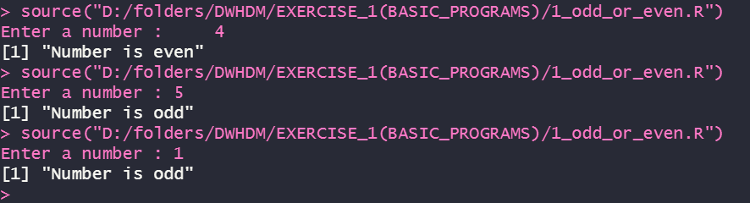

RESULT:

Thus the basic program odd or even was executed successfully.

EXPERIMENT-6

**MEAN, MEDIAN, MODE**

AIM:

To write the program for Mean, Median, Mode using R-Programming.

PROGRAM:

MEAN

names<-c("siri","mahi","chiru")

age<-c(23,24,25)

marks<-c(88,78,25)

df<-data.frame(names,age,marks)

mean(df $age)

write.csv(df,"datafr.csv")

MEDIAN

names<-c("siri","mahi","chiru")

age<-c(23,24,25)

marks<-c(88,78,25)

df<-data.frame(names,age,marks)

median(df $age)

write.csv(df,"datafr.csv")

MODE

names<-c("siri","mahi","chiru")

age<-c(23,24,25)

marks<-c(88,78,25)

df<-data.frame(names,age,marks)

mode(df $age)

write.csv(df,"datafr.csv")

OUTPUT:









RESULT:

**Thus the central tendency and measure of dispersion is executed successfully.**

EXPERIMENT-7

SUMMARY:

AIM:

To write the program for summary using R-tool.

PROGRAM:

names<-c("siri","mahi","chiru")

age<-c(23,24,25)

marks<-c(88,78,25)

df<-data.frame(names,age,marks)

summary(df $age)

write.csv(df,"datafr.csv")

OUTPUT:

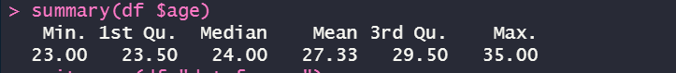

RESULT:

Thus the central tendancy and measure of dispersion is executed successfully.

EXPERIMENT-8

GREATER AMONG THREE NUMBERS:

AIM:

To write the program for the greatest among three numbers.

PROGRAM:

x <- as.integer(readline(prompt = "Enter first number :"))

y <- as.integer(readline(prompt = "Enter second number :"))

z <- as.integer(readline(prompt = "Enter third number :"))

if (x > y && x > z) {

print(paste("Greatest is :", x))

} else if (y > z) {

print(paste("Greatest is :", y))

} else{

print(paste("Greatest is :", z))

}

OUTPUT:

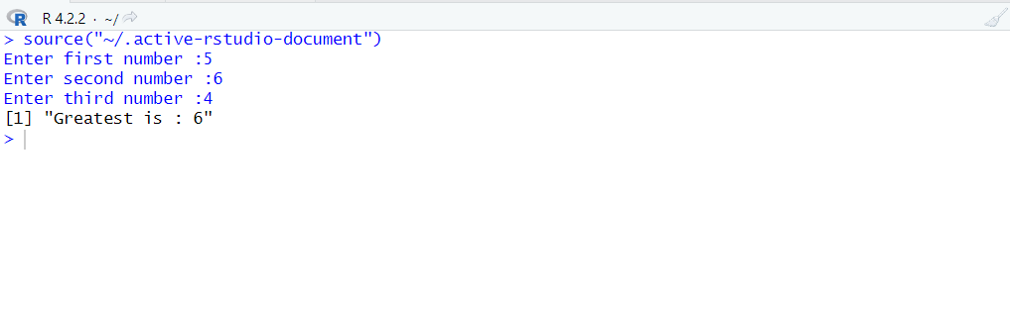

RESULT:

Thus the greatest among the three numbers was executed successfully.

EXPERIMENT-9

IQR:

AIM:

To write the program for central tendency and data dispersion measures using R tool.

PROGRAM:

names<-c("siri","mahi","chiru")

age<-c(23,24,25)

marks<-c(88,78,25)

df<-data.frame(names,age,marks)

IQR(df $age)

write.csv(df,"datafr.csv")

OUTPUT:



RESULT:

Thus the program for central tendency and data dispersion measures was executed successfully.

EXPERIMENT-10

QUANTILE:

AIM:

To write the program for central tendency and data dispersion measures.

PROGRAM:

names<-c("siri","mahi","chiru")

age<-c(23,24,25)

marks<-c(88,78,25)

df<-data.frame(names,age,marks)

quantile(df $age)

write.csv(df,"datafr.csv")

OUTPUT:

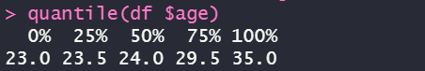

RESULT:

Thus the program for central tendency and data dispersion measures was executed successfully

EXPERIMENT-11

MID RANGE:

AIM:

To write the program for central tendency and data dispersion measures.

PROGRAM:

names<-c("siri","mahi","chiru")

age<-c(23,24,25)

marks<-c(88,78,25)

df<-data.frame(names,age,marks)

mid range(df $age)

write.csv(df,"datafr.csv")

OUTPUT:



RESULT:

Thus the program for central tendency and data dispersion measures was executed successfully

EXPERIMENT-12

Z-SCOORE NORMALIZATION:

AIM:

To write the program for Z-scoore normalization using R-tool.

PROGRAM:

diabetest1<-read_excel("C:/Users/M.Geetha/Downloads/NARA.xlsx")

A<-c(diabetest1$Age)

Mean<-mean(A)

Std<-sd(A)

Zscore<-(A-Mean)/Std

Zscore

OUTPUT:

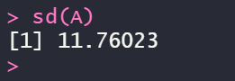

RESULT:

Thus the Z-scoore normalization using R tool was executed successfully.

EXPERIMENT-13

MIN,MAX,MEAN,MINMAX:

AIM:

To write the program for the minimum,maximum,mean and minmax using r-TOOL

PROGRAM:

MEAN

diabetest1<-read_excel("C:/Users/M.Geetha/Downloads/NARA.xlsx")

A<-c(diabetest1$Age)

Mean<-mean(A)

OUTPUT:

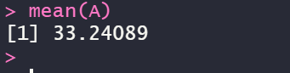

MINIMUM

diabetest1<-read_excel("C:/Users/M.Geetha/Downloads/NARA.xlsx")

A<-c(diabetest1$Age)

Minimum<-Min(diabetest1$Age)

OUTPUT:

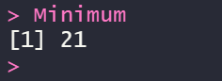

MAXIMUM

diabetest1<-read_excel("C:/Users/M.Geetha/Downloads/NARA.xlsx")

A<-c(diabetest1$Age)

Maximum<-Max(diabetest1$Age)

OUTPUT:



MINMAX

diabetest1<-read_excel("C:/Users/M.Geetha/Downloads/NARA.xlsx")

A<-c(diabetest1$Age)

Maximum<-Max(diabetest1$Age)

Minimum<-Min(diabetest1$Age)

MinMax<-(A-Minimum)/(Maximum-Minimum)

MinMax

OUTPUT:

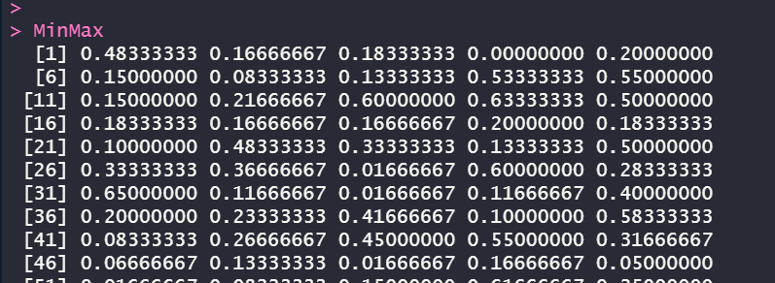

RESULT:

Thus the program for min,max,minmax,mean was executed successfully.

EXPERIMENT-14

BAR PLOT AND HORIZONTAL BAR:

AIM:

To draw the bar plot and horizontal bar using R-tool.

PROGRAM:

a<-c(55,67,89,80,90)

barplot(a)

a<-c(55,67,89,80,90)

barplot(a)

barplot(a,horiz=TRUE)

OUTPUT:

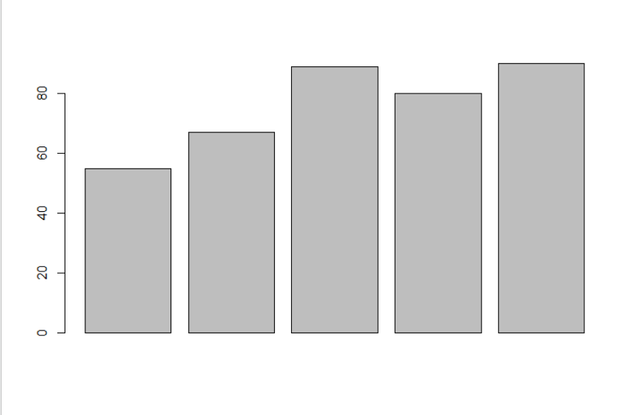

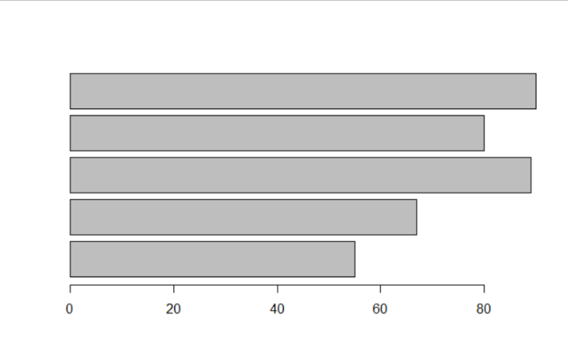

RESULT:

Thus the bar and horizontal bar plot was executed successfully.

EXPERIMENT-15

BOX PLOT:

AIM:

To draw the box plot using R-tool.

PROGRAM:

names<-c("siri","chru","loki")

age<-c(23,24,25)

marks<-c(88,78,25)

df<-data.frame(names,age,marks)

hist(df$age)

boxplot(df$age)

OUTPUT:

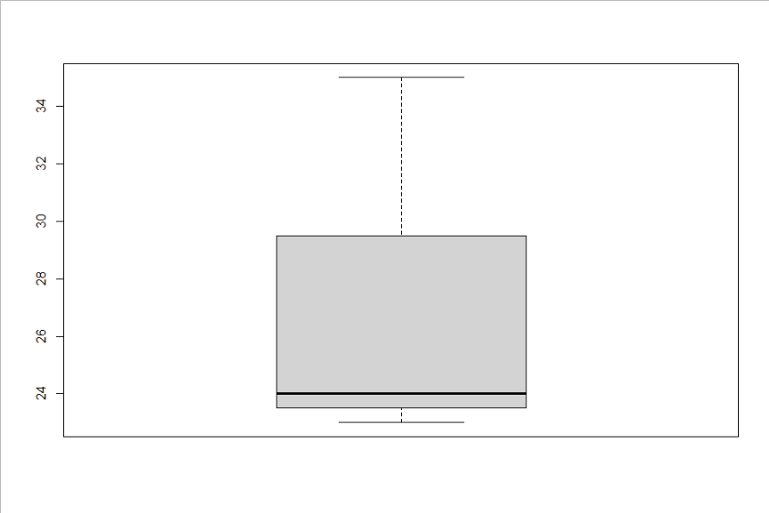

RESULT:

Thus the box plot was executed successfully.

EXPERIMENT-16

HISTOGRAM:

AIM:

To draw the histogram plot using R-tooll.

PROGRAM:

a<-c(55,67,89,80,90)

hist(a)

OUTPUT:

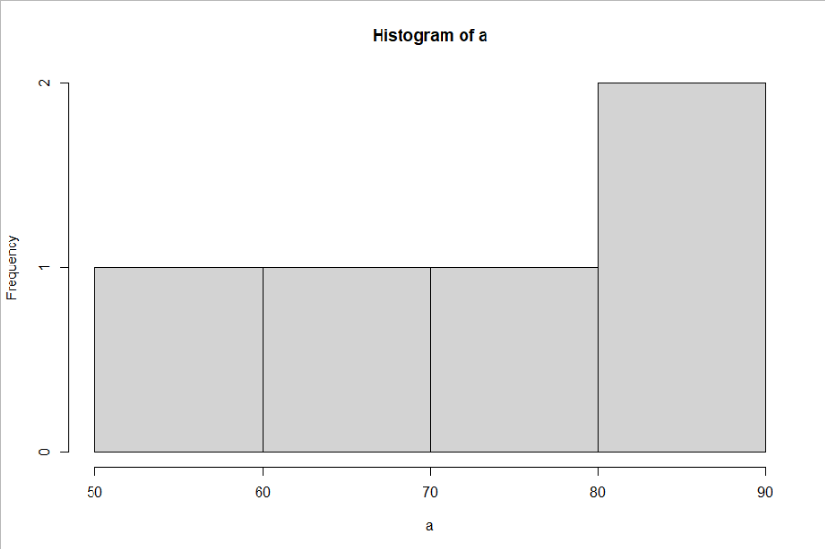

RESULT:

Thus the histogram plot was executed successfully.

EXPERIMENT-17

CORRELATION ANALYSIS:

AIM:

To write the program for correlation analysis using R-tool.

PROGRAM:

diabetest1<-read_excel("C:/Users/M.Geetha/Downloads/NARA.xlsx")

diabetest1<-table(diabetest1 $Age,diabetest1 $Insulin)

diabetest1

chisq.test(diabetest1)

OUTPUT:

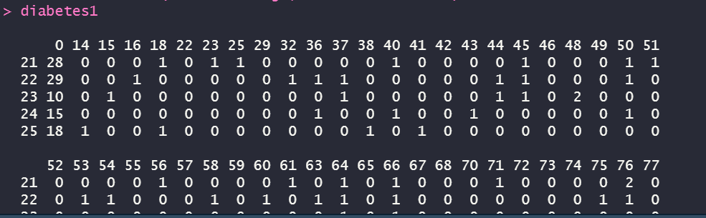

RESULT:

Thus the correlation analysis was executed successfully.

EXPERIMENT-18

SCATTER PLOT:

AIM:

To draw the scatter plot using R-tool

PROGRAM:

set.seed(9)

x <- rnorm(1000)

y <- rnorm(1000)

smoothScatter(y - x)

smoothScatter(x,y)

OUTPUT:

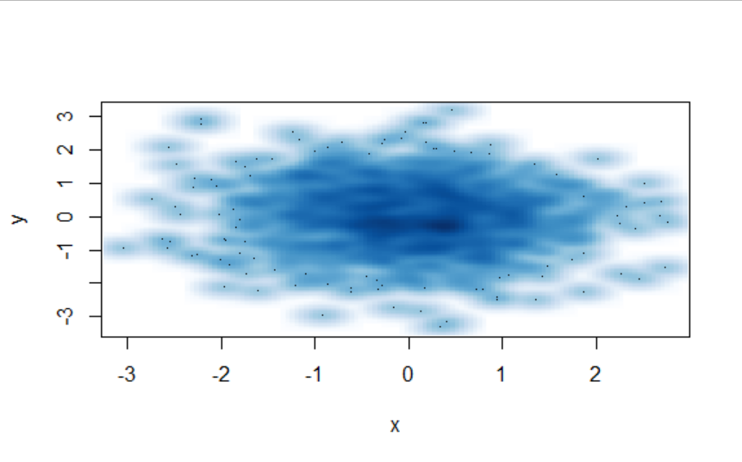

RESULT:

Thus the scatter plot was executed successfully.

EXPERIMENT-19

LINEAR REGRESSION:

AIM:

To write thr program for the linear regression using R-tool.

PROGRAM:

Relation <- lm(diabetes$BloodPressure~diabetes$Age)

Png<- (file=”linear regression.png”)

Plot(diabetes$Age, diabetes$BloodPressure, col=”green”, main= “ Linear Regression Analysis” , abline= (lm(diabetes$BloodPressure~ diabetes$Age)), xlab = “BloodPressure”, ylanb= “Age”)

OUTPUT:

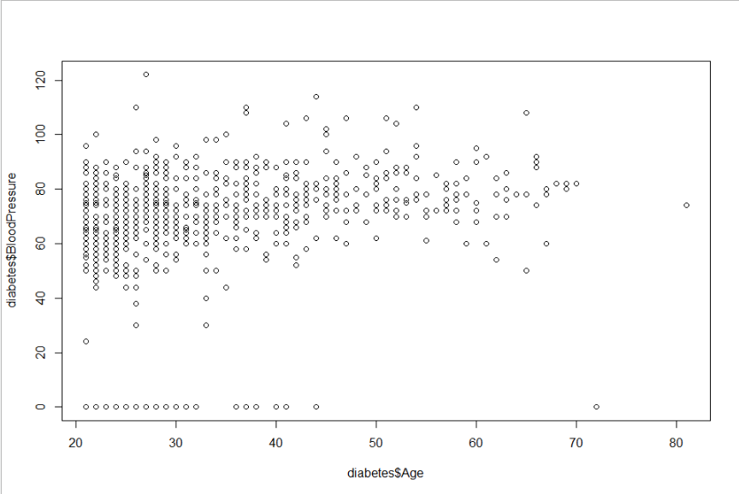

**RESULT:**

**Thus the linear regression program was executed successfully.**

**EXPERIMENT-20**

**MULTIPLE REGRESSION:**

**AIM:**

**To write the program for the multiple regression.**

**PROGRAM:**

Input <- diabetes[,c(“Age”, “BloodPressure”, “Glucose”)]

Model <- lm(Age~ BloodPressure+Glucose,data=input)

Print(model)

OUTPUT:

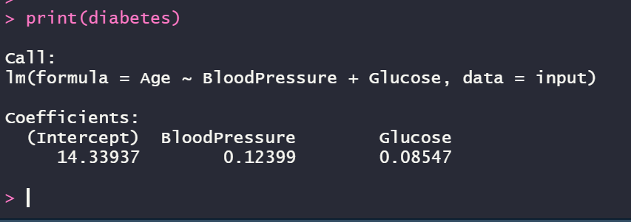

A<- coef(model)[1]

Print(A)

OUTPUT:

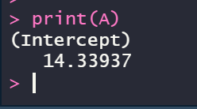

xBloodPressure<- coef(model)[2]

yGlucose<- coef(model)[3]

print(xBloodPressure)

print(yGlucose)

**OUTPUT:**

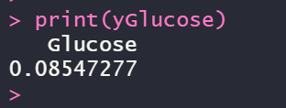

y = A+xBloodPressure + yGlucose

print(y)

**OUTPUT:**

